D211 Advanced Data Acquisition
D211 Advanced Data Acquisition
Representation and Reporting
Instructor: Dr. William Sewell
Student Name: Devon E. Johnson
Student ID: 011494484
Email: djo3593@wgu.edu

A1: Data Sets for Dashboard
The dashboard references two datasets: the cleaned medical dataset from WGU and a publicly available dataset from the Behavioral Risk Factor Surveillance System (BRFSS) survey conducted by the CDC in 2020. The BRFSS survey is the largest continuously conducted health survey system in the world, completing more than 400,000 adult interviews every year to assess the health status of U.S. residents across all 50 states as well as the District of Columbia and three U.S. territories (Kumar, 2025). Of the 279 original attributes, I used six variables that I could compare to variables within the WGU dataset: BMI, Stroke, Sex, AgeCategory, Diabetic, and Asthma.
A2: Dashboard Instructions
The process to have this dashboard appear fully operational in Labs on Demand is a bit tedious, as the environment itself can be difficult to navigate. The simplest process is as follows:
- Download the “D211 Advanced Data Acquisition.twbx” file from the attached files in the assignment submission.
- Email this file to your preferred email address.
- Open the Labs on Demand environment.
- Use Edge to navigate to your email.
- Open the “D211 Advanced Data Acquisition.twbx” file.
- The file should automatically open in Tableau, fully operational. In the event that it does not automatically open in Tableau, right-click the file in downloads and select “Show in Folder” to see the file in File Explorer. From here, right-click the file again and select “Open With” and then “Tableau.”
- Recommendation: Click the presentation icon in the upper ribbon or hit “F7” to activate Presentation Mode. This makes the story occupy the entire screen so you avoid viewing the individual sheets and dashboards that were used to build the story.
As Labs on Demand does not communicate with one’s personal work station at all, it is impossible, as far as I can tell, to otherwise transfer files between a regular desktop and the remote desktop environment.

A3: Dashboard Navigation
The first dashboard provides an overview of the patient demographics from both datasets, using age and gender as distinctive categories for comparison. Age distribution is demonstrated as two bar charts, one for the CDC and one for WGU, and gender distribution is demonstrated as two pie charts, again, one for the CDC and one for WGU. Three side filters allow the user to easily filter the results to narrow to one or multiple results for either gender, age category, or source. These filters apply to all charts on the first dashboard.
The second dashboard contains four separate heat maps for the four different common conditions between the WGU and CDC datasets: asthma, overweight, diabetes, and stroke. Each heat map has a corresponding legend that shows the minimum and maximum values of the color range. A table above each legend also shows the occurrence of each condition in the respective datasets as a percentage.
Finally, the third dashboard contains a succinct text summary, without charts or visualizations, that summarizes the data presented. This serves to aid audience members who may be less inclined to interpret visual cues alone and prefer to also benefit from a readable summary.
A4: Supporting Code
All of my supporting code was executed in pgAdmin4 using SQL:
- Creation of table for the CDC dataset:
DROP TABLE IF EXISTS public.heart_2020_cleaned;
CREATE TABLE IF NOT EXISTS public.heart_2020_cleaned
(
HeartDisease VARCHAR(10),
BMI DECIMAL(5,2),
Smoking VARCHAR(10),
AlcoholDrinking VARCHAR(10),
Stroke VARCHAR(10),
PhysicalHealth INT,
MentalHealth INT,
DiffWalking VARCHAR(10),
Sex VARCHAR(10),
AgeCategory VARCHAR(20),
Race VARCHAR(50),
Diabetic VARCHAR(50),
PhysicalActivity VARCHAR(10),
GenHealth VARCHAR(20),
SleepTime INT, Asthma VARCHAR(10),
KidneyDisease VARCHAR(10),
SkinCancer VARCHAR(10)
);

- Importing data for the CDC datset using the PSQL tool:
\copy heart_2020_cleaned FROM 'C:\Users\My Name Devon\OneDrive\Documents\WGU MSDA\D211\heart_2020_cleaned.csv' DELIMITER ',' CSV HEADER
- Creation of table for the WGU dataset:
DROP TABLE IF EXISTS public.wgu_clean;
CREATE TABLE IF NOT EXISTS public.wgu_clean
(
CaseOrder INTEGER,
Customer_id VARCHAR(50),
Interaction VARCHAR(50),
UID VARCHAR(50),
City VARCHAR(100),
State VARCHAR(50),
County VARCHAR(100),
Zip INTEGER,
Lat DECIMAL(10,8),
Lng DECIMAL(11,8),
Population INTEGER,
Area VARCHAR(50),
"TimeZone" VARCHAR(50),
Job VARCHAR(100),
Children INTEGER,
Age INTEGER,
Income DECIMAL(12,2),
Marital VARCHAR(50),
Gender VARCHAR(20),
ReAdmis VARCHAR(20),
VitD_levels DECIMAL(10,2),
Doc_visits INTEGER,
Full_meals_eaten INTEGER,
vitD_supp INTEGER,
Soft_drink VARCHAR(20),
Initial_admin VARCHAR(50),
HighBlood VARCHAR(20),
Stroke VARCHAR(20),
Complication_risk VARCHAR(20),
Overweight VARCHAR(20),
Arthritis VARCHAR(20),
Diabetes VARCHAR(20),
Hyperlipidemia VARCHAR(20),
BackPain VARCHAR(20),
Anxiety VARCHAR(20),
Allergic_rhinitis VARCHAR(20),
Reflux_esophagitis VARCHAR(20),
Asthma VARCHAR(20),
Services VARCHAR(100),
Initial_days DECIMAL(10,2),
TotalCharge DECIMAL(12,2),
Additional_charges DECIMAL(12,2),
Item1 INTEGER,
Item2 INTEGER,
Item3 INTEGER,
Item4 INTEGER,
Item5 INTEGER,
Item6 INTEGER,
Item7 INTEGER,
Item8 INTEGER
);
- Importing data for the WGU datset using the PSQL tool:
copy public.wgu_clean FROM 'C:\Users\My Name Devon\OneDrive\Documents\WGU MSDA\D211\medical_clean.csv' DELIMITER ',' CSV HEADER

- Cleaning script for WGU data and creation of new “cleaned” table
DROP TABLE IF EXISTS final_wgu_clean CASCADE;
CREATE TABLE final_wgu_clean AS
SELECT
'WGU' AS source,
Stroke AS stroke,
Gender AS gender,
CASE
WHEN Age BETWEEN 0 AND 24 THEN '18-24'
WHEN Age BETWEEN 25 AND 29 THEN '25-29'
WHEN Age BETWEEN 30 AND 34 THEN '30-34'
WHEN Age BETWEEN 35 AND 39 THEN '35-39'
WHEN Age BETWEEN 40 AND 44 THEN '40-44'
WHEN Age BETWEEN 45 AND 49 THEN '45-49'
WHEN Age BETWEEN 50 AND 54 THEN '50-54'
WHEN Age BETWEEN 55 AND 59 THEN '55-59'
WHEN Age BETWEEN 60 AND 64 THEN '60-64'
WHEN Age BETWEEN 65 AND 69 THEN '65-69'
WHEN Age BETWEEN 70 AND 74 THEN '70-74'
WHEN Age BETWEEN 75 AND 79 THEN '75-79'
WHEN Age >= 80 THEN '80 or older'
END AS age_category,
Diabetes AS diabetes,
Asthma AS asthma,
Overweight AS overweight
FROM public.wgu_clean;

- Cleaning script for CDC data and creation of new “cleaned” table
DROP TABLE IF EXISTS final_brfss_clean CASCADE;
CREATE TABLE final_brfss_clean AS
SELECT
'CDC' AS source,
Stroke AS stroke,
Sex AS gender,
AgeCategory AS age_category,
Diabetic AS diabetes,
Asthma AS asthma,
CASE
WHEN BMI <= 24.9 THEN 'No'
WHEN BMI > 24.9 THEN 'Yes'
END AS overweight
FROM public.heart_2020_cleaned
LIMIT 10000;
- Creation of combined dataset
DROP TABLE IF EXISTS combined_df_clean CASCADE;
CREATE TABLE combined_df_clean AS
SELECT * FROM final_wgu_clean
UNION ALL
SELECT * FROM final_brfss_clean;
B1: Panopto Presentation
My Panopto Presentation may be viewed at the following link: D211 Advanced Data Acquisition Panopto Presentation
C1: Dashboard Purpose and Function
My dashboard's purpose is to support executive decision making by enabling leaders to explore the data, identify trends, and compare key metrics. The data dictionary explains that the Senior Vice President of Hospital Operations (SVP) is specifically interested in the demographic distribution of patient treatment and outcomes and how this may apply to patient care to guide strategic improvements in the field. I designed my dashboard with these priorities in mind, attempting to provide a clear understanding of the demographic distribution of patient treatment and outcomes within WGU and to compare these trends to a broader national sample. To fulfill this, I chose the CDC's 2020 BRFSS survey as a comparative dataset, as it offers publicly available data on patient age and gender in relation to conditions also found in the WGU dataset: asthma, diabetes, overweight, and stroke. Comparing WGU's internal data to this national dataset allows executive leaders to assess whether observed trends at WGU are unique or reflective of broader societal patterns.
C2: Business Intelligence Tool
I used Tableau as my business intelligence tool because of its ease of use as well as its choice of clean and insightful visualizations. I have prior experience navigating Tableau from the last class, D210 and was easily able to link the new dataset derived from my SQL script to my prior dashboard and modify it accordingly. Tableau also allows users to interact with the data to derive their own insights, rather than just providing a static visualization from one perspective. To capitalize on this feature, I embedded three interactive filters (age category, gender, and data source) across all the data visualizations.
C3: Data Cleaning
To properly compare the two datasets, I still needed to conduct some level of data transformation in pgAdmin using SQL. To clean the CDC dataset, I needed to address the issue of BMI, as WGU only had a binary variable for Overweight. As such, I converted all BMI values in the CDC dataset over 24.9 to “Yes” and all values equal to or under 24.9 to “No” and renamed the variable “overweight” to match the dataset from WGU. I also limited the output in the cleaned CDC dataset to only contain 10,000 results, so that it would have an equal number of records to the cleaned WGU dataset.
To clean the WGU dataset, I needed to address the Age variable, as WGU stored this as a continuous variable and the CDC dataset stored it in bins. As such, I transformed the WGU dataset to bin all ages to match the bins defined in the CDC dataset, e.g. 18-24, 25-39, 40-44, etc., and including all ages equal to or above 80 in a single bin, 80 or Older.
I also renamed all variables in the WGU and CDC datasets to match and follow proper naming conventions, e.g. lowercase and underscored where appropriate. Since I joined my two datasets into one merged dataset for ease of dashboard creation in Tableau, I created an additional variable called “source” that is either equal to “WGU” or “CDC” depending on the origin of the data. For visibility, the Entity-Relationship Diagram (ERD) below may be referenced to better understand the relationships between the merged datasets using a UNION operation:
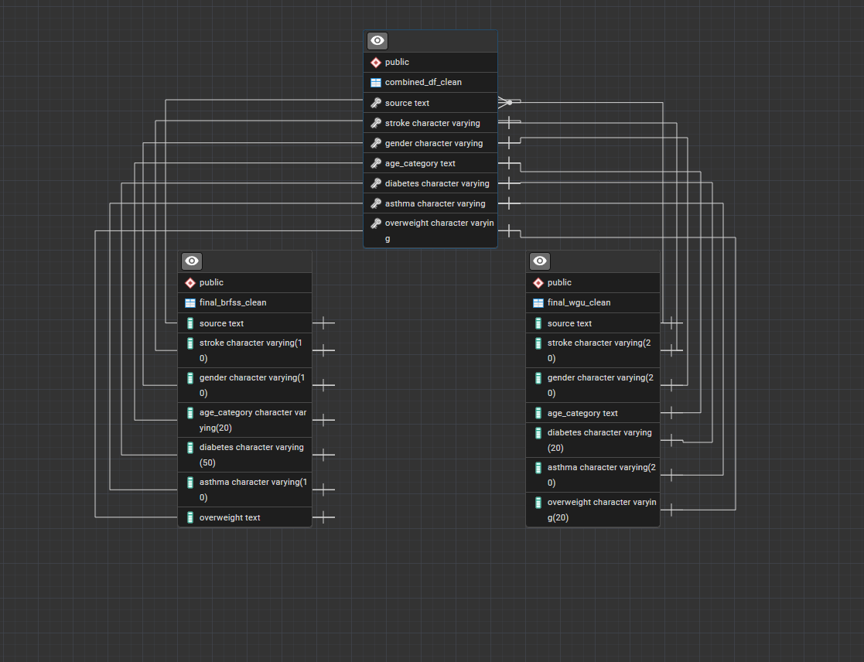
C4: Dashboard Creation
As the underlying data for this dashboard creation was identical to the data used in D210, I saved the combined_df file created in SQL as an xlsx file, opened my previous twbx file from D210, and imported the new combined_df_clean_xlsx file as my new datasource.
Initially, I created my Tableau story by first establishing all of the component charts on separate sheets and dashboards. I created a bar chart for “Patient Age Distribution” by using the variables “Source” and “Age Category” as columns and the associated count for each age bracket as the rows (or bars). For this sheet, I used Age Category, Source, and Gender as optional filters. I also created two pie charts for the CDC and WGU, using the Source variable in the columns section, dragging the “Gender” variable into the color scheme and showing the count of each Gender as a section of the pie charts. For this sheet, I used Gender, Age Category, and Source as optional filters.
For the second slide of my story, I needed to create heat maps for each condition as they occurred in different age categories across the two different datasets. I made individual heat maps for each condition on different sheets, putting the Age Category variable into the Columns section and the Source variable into the Row section. Each condition variable, e.g. Asthma, was used as the color scheme, showing the count of each condition occurrence in each age category as a specific shade, with darker red colors indicating a higher prevalence and darker blue colors indicating a lower prevalence. For each of these sheets, I created an additional sheet that contained a chart showing the overall percentage occurrence of each condition in each source category. An interactive filter was used on each sheet including gender, age category, and source as optional filters. Another filter automatically set the condition to always equal “Yes” so that the charts accurately demonstrated only positive results for the medical conditions being explored.
I combined my first set of charts, Patient Age Distribution and Patient Gender Distribution into one dashboard and my second set of charts for each condition, Asthma, Diabetes, Overweight, and Stroke, into another dashboard. I then created a third dashboard consisting only of text where I succinctly summarized the results of my data analysis. I then combined all three of these dashboards into a three-party “story” which represents the full project in Tableau.
C5: Data Analysis Results
Both datasets show similar gender distributions with slightly more females than males (CDC: 52% female, 48% male; WGU: 51% female, 48% male, 1% nonbinary). Meanwhile, the age distributions are more contrasted, as the CDC data shows relatively even distribution across age groups while the WGU data has a significant spike in the "80 or older" category.
Asthma: More prevalent in the WGU data (67.72%) vs the CDC (32.38), with WGU showing the greatest density in patients 80 or older.
Diabetes: More prevalent in the WGU data (66.12%) vs the CDC (33.88), with CDC data showing concentration in patients aged 65-74 and WGU showing the greatest density in patients 80 or older.
Overweight: Nearly even distribution between sources (CDC: 49.47%, WGU: 50.53%), with the CDC showing the most concentration in patients aged 50 to 74 and WGU showing the greatest density in patients 80 or older.
Stroke: Dramatically different (CDC: 16.65%, WGU: 83.35%), with WGU showing much higher prevalence across all age groups, but, as with the other three conditions, showing the greatest density in patients 80 or older.
The heat maps reveal that WGU data consistently shows higher prevalence of conditions in older populations, while CDC data tends to show more even age distribution across conditions. That said, WGU's elderly-heavy population naturally drives higher prevalence of age-related conditions like stroke and diabetes, since these conditions disproportionately affect older adults.
These analytic results support the purpose and function of my dashboard by representing the unique qualities of the WGU patient population. The comparison shows that WGU appears to represent a geriatric or specialized elderly care population, while CDC likely represents a more general population sample. This may indicate that WGU should focus on incorporating appropriate treatment plans aligned with geriatric care and hiring geriatric specialists rather than expecting to apply the same level of preventative care across all age groups.
C6: Limitations of Data Analysis
One major limitation of my data analysis is that my comparison data is potentially outdated, as it is derived from a CDC study conducted in 2020. That said, WGU does not clarify when their data was collected, so we do not know how comparable our two datasets are in terms of collection date. Another legitimate issue is posed by the initial issue of age categorization, though we addressed this to the extent of our capabilities during the data cleaning process. Since the CDC top-codes patients aged past 80 years old while WGU maintains continuous age values potentially extending well beyond 80 years old, we do not know how old the upper spectrum of the CDC patient sample is. As health issues tend to compound with age, if WGU included more older patients with more substantial health problems while the CDC did not include such older patients, then it might be skewing the results to make it appear that WGU patients have more health conditions when the issue is actually that the CDC just did not include that more at-risk age range in their dataset.
D. Code References
Import CSV file into PosgreSQL table. (n.d.). Neon. https://neon.com/postgresql/postgresql-tutorial/import-csv-file-into-posgresql-table
Kumar, S. (2023, December 5). Understanding CASE WHEN: Making transformation easy. Medium. https://medium.com/@sumitkum001/understanding-case-when-making-transformation-easy-e3ca5ca3c950
SQL tutorial. (2025, August 20). GeeksforGeeks. https://www.geeksforgeeks.org/sql/sql-tutorial/
E. Source References
Johnson, D. (2025). D210 Data Dashboard and Storytelling.
Kumar, K. (2025, May 4). BRFSS 2020 heart disease Dataset(Cleaned version). Zenodo. https://zenodo.org/records/15336526

